**ALMA MATER SOCIETY**

# ASSEMBLY REPORTS

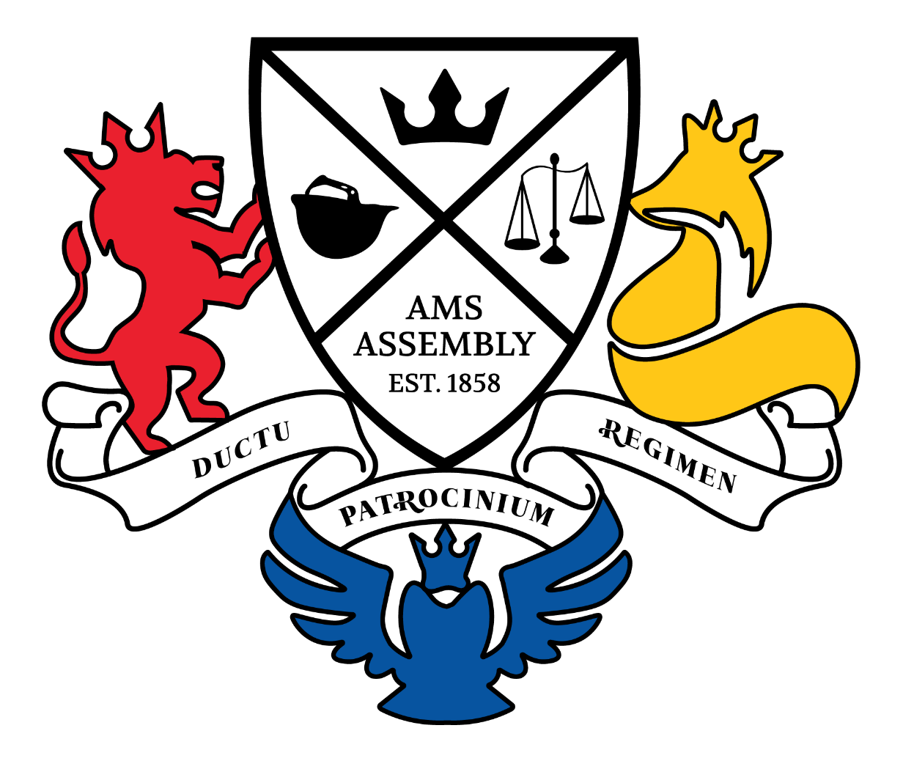

September

MISSION STATEMENT

***To serve and represent the diversity of students at Queen's University*.**

MANDATE

To represent Queen’s University students within the university and externally by working to further the best interests of the members of the AMS, giving particular concern to representation on issues related to education.

To provide experiential, out-of-classroom opportunities to develop skills and learn, through the provision of services and programs.

To uphold the principles of Indigenization, Equity, Diversity, Inclusion, Anti-Racism, Accessibility (I-EDIAA) within the Queen’s community and on behalf of Queen’s undergraduate students.

To serve as a liaison between the various affiliated student societies

Contents

ASSEMBLY REPORTS 1

President of the Alma Mater Society 3

Vice President of University Affairs 4

Vice President of Operations 5

Office of the Secretariat 6

Commision of the Orientation Roundtable Coordinator 7

Commission of Clubs 8

Commission of External Affairs 9

Commission of Campus Affairs 10

Commission of Social Issues 11

Commission of Environmental Sustainability 12

Chair of the AMS Board of Directors 13

Arts & Science Undergraduate Society 14

Engineering Society 15

Smith Commerce Society 16

Health Sciences Society 17

Computing Students’ Association 18

Concurrent Education Students’ Association 19

Physical Education & Kinesiology Students’ Association 20

Nursing Science Society 21

Queen’s Student Alumni Association 22

Residence Society President & CEO 23

Undergraduate Student Trustee 24

Student Senate Caucus Chair 25

Office of the Rector 26

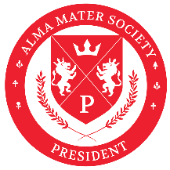President of the Alma Mater Society

**Report to Assembly**

**Jana Amer**

[**president@ams.queensu.ca**](mailto:president@ams.queensu.ca)

September 16th, 2025

**REPORT TO AMS ASSEMBLY**

It is with deep gratitude and excitement that I submit my fifth report to AMS Assembly as the 156th President of the Alma Mater Society.

I can’t believe we’ve already finished two weeks of classes. The energy of students being back on campus has reenergized me and set the tone for the year ahead.

Orientation was truly magical. Watching incoming and returning students work together so harmoniously to welcome everyone into our campus community reminded me once again that Queen’s is not just where you study—it’s where you find home.

These past couple of weeks have been fast-paced and productive, with significant behind-the-scenes work to advance projects and strengthen operations. I can’t wait for everyone to see what’s ahead.

**PORTFOLIO |** What my team and I have been up to?

**Marketing |** The team has been finalizing the JDUC trailer, launching the Student Experience Survey, and representing AMS at Queen’s in the Park, Sidewalk Sale, and Princess Promenade. We made sure to attend at least one event per faculty, filmed four AMS Asks U series, and onboarded our new graphic designer and brand ambassadors. Work is also underway on redesign concepts for the QC pillar wraps while supporting preparations for the JDUC Grand Opening.

**Communications |** This portfolio has been focused on accuracy and clarity. We have fact-checked and updated website content, prepared to launch the Advocacy Toolkit, and completed final drafts of the Annual Report. A full content audit identified outdated material, and we launched the first newsletter while preparing a blog revamp. The team has onboarded new members, including the Executive Assistant, and is supporting both the JDUC Grand Opening and the Alumni Relations event.

**Orientation Roundtable (ORT) |** Orientation 2025 was a tremendous success. The team delivered one of the smoothest Orientation experiences in recent memory, with no major issues. Their professionalism was recognized with congratulations from the City of Kingston, reflecting the hard work and diligence that went into planning. Orientation also created moments of joy and pride for the entire Queen’s community. The team is now shifting focus to preparing invoices and supporting the transition for next year’s team.

**Student Life Centre (SLC) |** The team has successfully completed supporting the Queen’s Journal move and is overseeing JDUC infrastructure projects and student club relocations. They are also onboarding Keycafe to improve key management and access control across AMS facilities. To kick off the year, the SLC hosted a live music night that was well received by students. Alongside this, they remain heavily involved in JDUC Grand Opening preparations.

**Internal Affairs |** The Internal Affairs team is now fully staffed (WOOHOO!) and has been working to clarify membership clauses while finalizing Faculty Society fee memos through consultation. They have been following up on Judicial Council sanctions and launched a review of the Judicial Policy to ensure clarity and consistency. Tri-Review notices have been issued, and a master fee-tracking list is being developed to improve oversight moving forward.

**Information Technology (IT) |** IT is in the process of hiring the IT Tech Student position and has been assisting with onboarding for Bounce, AMS systems, and the Help Desk. The team is also preparing to launch DocuSign integration for MOU and contract management. Development of new transition training modules is underway to improve institutional memory and onboarding practices.

**Human Resources (HR) |** The team has completed onboarding for summer hires, addressed overdue training, and launched the Investigations Toolkit. Weekly personnel policy updates are being prepared, while planning continues for the Hiring Fair and Career Fairs. Hiring for First-Year Intern Night has been launched, and the team has begun mapping out volunteer appreciation initiatives.

**UPDATES |** What I have been up to?

**University Engagement & Advocacy |** I have continued to participate in Sustainable Development Goals (SDG) initiatives while attending Senate committees, the Student Senate Reception, and Bicentennial Visioning Group meetings. Conversations with the University have focused on clarifying membership updates and reworking the data-sharing agreement to ensure it meets AMS needs. I have also been in discussion with Senate Governance about the potential for a new Bachelor of Health Sciences seat, as BHSc students currently lack direct representation despite being the largest undergrad group in Health Sciences.

**Athletics & Recreation |** My work with Athletics & Recreation has been centered on transparency and ensuring student value for AMS Athletic Fees. At the same time, the partnership with the Varsity Leadership Council continues to support both athletes and charity initiatives.

**Equity & Accessibility |** I have been collaborating with the Human Rights and Equity Office (HREO) to review accommodations and exemptions for the mandatory fee slate in compliance with AODA. This work is vital in ensuring accessibility and fairness across the AMS fee structure.

**Health & Dental**| Engagement with our provider has focused on exploring options for exchange student access to AMS health and dental coverage. The Health and Dental team has also been present at every major boothing opportunity on campus to educate students about the plan. I am working to ensure that AMS leaders and ambassadors have a strong understanding of coverage so they can better support students.

**Prayer Spaces** | Advocating for consistent and equitable prayer spaces remains a top priority. I have continued to work with the University to ensure that QUMSA and Muslim students have year-round, accessible spaces for religious practice.

**Orientation** | Attending Orientation events this year left me in awe. The harmony, excitement, and dedication shown by our Orientation leaders and students made me incredibly proud to be part of such a community.

**Social & Cultural Initiatives** | Planning and executing programming for the National Day for Truth and Reconciliation (NDTR) is underway. I am working closely with the committee on sacred fire coordination and programming, and I am preparing remarks for the sacred fire gathering.

**Closing Reflections |** Only two weeks into the year, I am already so proud of our progress and excited for what lies ahead. Thank you to our students, colleagues, and peers for your dedication and commitment.

 Let’s continue to listen, act, and collaborate to build a stronger student experience.

Cha Gheill,

   
**Jana Amer (she/her)**

156th President, Alma Mater Society

613-533-6000 ext. 32726   
[president@ams.queensu.ca](mailto:president@ams.queensu.ca)

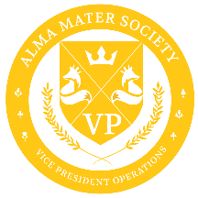Vice President of Operations

**Report to Assembly**

**Elena Nurzynski**

[**vpops@ams.queensu.ca**](mailto:vpops@ams.queensu.ca)

Hello Assembly,

Summer has flown by, and I hope you are all having a smooth start to the school year. September has been a busy time under the VPOPs umbrella. All services are officially open and operating for the 2025-26 school year after conducting staff training at the end of August. Services are focusing on supporting their new teams of service staff and supervisors as they adjust to their new roles, and many have spent the first week of September engaging with students through various orientation events, including Sidewalk Sale and Queen’s in the Park.

Please see below for service operating hours for the 2025-26 school year:

AMS Services Operating Hours:

AMS Media Centre

* Creative Hub:
  + Mon-Fri: 10am-4pm
* Production Hub:
  + Mon-Fri: 9am-5pm

The Brew

* Mon-Fri: 9am-4pm

Common Ground Coffeehouse

* Mon-Thurs: 8am-8pm
* Fri: 8am-6pm
* Sat-Sun: 10am-6pm

Foodbank

* Mon + Wed: 5pm-7pm
* Thurs: 12pm-2pm
* Peach Market
  + Mon, Wed, Fri: 11am-2pm

Queen’s Journal

* Print issues every Friday
* Online issues every Tuesday

Queen’s Pub & Restaurant

* Sun-Wed: 11:30 am-12pm
* Thurs-Sat: 11:30 am-1am

Queen’s StuCons

* By event basis
* Stationed: QPR 9pm every night
* Stationed: Clark Hall Pub Friday Ritual

Society58 (formerly Tricolour Outlet)

* Mon-Fri: 11am-6pm
* Sat: 11am-4pm

Peer Support Centre

* Mon-Sun: 10am-8pm

Walkhome

* Sun-Wed: 8pm-2am
* Thurs-Sat: 8pm-3am

*\*\* Operating hours are subject to change with the discretion of the VPOPS*

Additional Service Updates:

* The Brew: Officially opened its doors on Monday, September 8th after 5 years of being closed. The team is currently working hard to ensure smooth operations and quality service for customers.
* Queen’s Pub and Restaurant: JDUC Grand Re-Opening being hosted on September 19th and will feature the launch of their late-night student menu. I encourage everyone to attend the event and enjoy the Pub!
* Walkhome: Take Back the Night is coming up on September 18th – if you’re interested in volunteering please reach out to Niki at [walkhome@ams.queensu.ca.](mailto:walkhome@ams.queensu.ca) I encourage everyone to come out and join this event that involves both stakeholders from the University and City of Kingston.

Consolidated Budget| The consolidated operating budget for the Alma Mater Society was approved by the Board of Directors during our session on August 27th. The budget will be presented to Assembly at the CAGM in November.

Bus-It | Tap cards have officially begun taking on phased implementation, starting with first year students. Additionally, as of Monday, Sept. 1, Kingston Transit has implemented several planned improvements and seasonal service adjustments to enhance service for students who utilize Kington Transit. Many of these service changes have been made with the knowledge that students are beginning to live further from campus.

The upcoming service changes will benefit student transit customers by:

· Increasing frequency, with more routes offering 15-minute or better service during peak periods, allowing students to travel to and from campus at a more efficient rate;

· Increasing access throughout the city by offering trips beyond typical travel hours

Please reach out if you have any questions or concerns, I am always happy to chat.

All my best,

Elena Nurzynski (She/Her/Hers)

Vice President of Operations | AMS

[vpops@ams.queensu.ca](mailto:vpops@ams.queensu.ca)

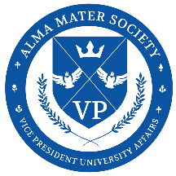Vice President of University Affairs

**Report to Assembly**

**Alyssa Perisa**

[**vpua@ams.queensu.ca**](mailto:vpua@ams.queensu.ca)

Dear Assembly,

I am very excited to welcome everyone to our first Assembly of the school year! This year is going to fly by with reports, motions and discussion items. My hope is that we can make the most of this space as a forum for open dialogue, collaboration, and feedback together.

**Advocacy Work**

Earlier this month, team JEA met with our Health & Dental Plan provider, Studentcare/Alumo, to discuss future directions of the plan, including gender affirmation care claims. One of my priorities this year is to ensure that every student can confidently navigate their claims and has access to the resources they need to make full use of the plan. To do this, there are discussions on having easier access to diagrams and walkthroughs for claim processing.

I also had an insightful meeting with Alex Pedersen the manager of EDII Capacity Development at the Arthur B. McDonald Canadian Astroparticle Physics Research Institute about menstrual equity. I learned more about the barriers faced not only by students, but also by Queen’s faculty, when it comes to advocating for accessible menstrual products. Alongside Commissioner Sy, we are reflecting on the original goals of the Menstrual Equity Project, particularly the purpose of the dispensers, and exploring whether it may be more effective to shift toward menstrual baskets.

Together with Commissioner Sy, I’ve also begun work on AMS Accessibility and Equity from an internal perspective. For too long, equity work has been siloed within the governance portfolio, and we are advocating for stronger accountability measures and organizational mandates across the AMS.

**Campus & Community**

Commissioner Ballaj has been hard at work organizing the first annual Community BBQ, an exciting new initiative aimed at strengthening town-gown relationships by connecting students with city stakeholders and community members. The town-gown relationship Is proving to be strong between the AMS and our city councilors, with Councilor Glenn and Cinanni showing support and donating to our Foodbank at the Sidewalk Sale. Please feel welcome to join us at the Community BBQ, where you can also speak directly with city councilors about your thoughts on Kingston and Queen’s.

**Clubs**

Commissioner Tronsgard has been reframing the Professional Development Day for clubs. To make the training accessible, we’ll host an in-person session with incentives to attend while also providing the content online. These trainings are mandatory, and this year we’ll be following up with clubs who have not completed them to ensure everyone is adequately prepared for the year and understands what it means to be an AMS-ratified club.

We are also beginning consultations on Clubs Policy with faculty societies before rewriting the policy. An ad-hoc committee will be struck to review it, and your feedback will be crucial in shaping its future direction.

At the Tricolour Open House, Commissioner Tronsgard’s leadership and perseverance were key to its huge success. I’ll leave the details to her report, but I want to give her special recognition here for the effort she put in to ensure a smooth and successful event.

**UNSDGs**

I met with Commissioner Schmidt to discuss the UN Sustainable Development Goals and how the AMS can meaningfully contribute to each one. Together, we’ve developed a framework of action items applicable to the AMS and are now creating timelines and accountability measures to ensure this work moves forward.

**OUSA**

We are currently exploring which Assembly members might be interested in attending this year’s Ontario Undergraduate Student Alliance (OUSA) General Assembly. While this opportunity was previously open to the general student body, we believe it is fitting for elected student leaders, those entrusted by their faculties to advocate on their behalf, to represent Queen’s at the provincial level. I strongly encourage those of you passionate about student advocacy to consider stepping into this role.

**Building Connections**

Over the past few weeks, I’ve greatly enjoyed connecting with the Vice Presidents of Affairs from each faculty society. These conversations have helped me better understand the unique strengths and challenges of each faculty, and I’m excited to continue supporting one another’s events and initiative throughout the year!

Overall, it has been a meaningful and productive first month, and I feel optimistic about the year. Thank you for the work you do in your societies and for the commitment you bring to Assembly. I’m looking forward to continuing this year together.

Warm regards,

Alyssa Perisa

Office of the Secretariat

**Report to Assembly**

**Emily Henrique**

[**secretariat@ams.queensu.ca**](mailto:secretariat@ams.queensu.ca)

Hello Assembly Members!

I hope everyone has had a restful summer break and a good start to the school year. I have officially taken on the Secretariat role, and I am so excited for our first official Assembly of the school year.

The Internal Affairs office has been hard at work preparing for our Fall referenda, aiding Faculty Societies in facilitating their elections, getting out Judicial system up and running, and of course planning for Assembly for the year.

**Civic Office**

* Our Fall election season has officially opened, and second notices have been sent to Tri-Review groups participating in our Fall referenda.
* Our CEO has also begun connecting with Faculty Societies to facilitate their internal elections. Your elections/governance officers should be expecting an email soon!

**Judicial Office**

* Our Judicial managers have been hard at work, planning training for our Judicial Council members and looking to update our website to aid students better understand how our Judicial system works, and how we can best support them.

If you have any questions, ideas or just to chat please do not hesitate to reach out.

Kindly,

Emily Henrique

Secretary of Internal Affairs

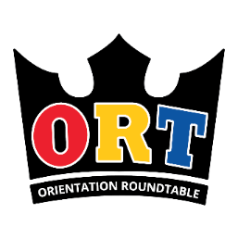Orientation Roundtable

**Report to Assembly**

**Jonathan Shenouda**

[**ort@ams.queensu.ca**](mailto:ort@ams.queensu.ca)

Commission of Clubs

**Report to Assembly**

**Xian Tronsgard**

[**clubs.manager@ams.queensu.ca**](mailto:clubs.manager@ams.queensu.ca)

Dear Members of Assembly,

The Commission of Clubs is thrilled to kick off another academic year supporting the incredible students and clubs at Queen’s! This month, we’ve connected with students at various events, including presenting at NEWTS (New, Exchange, World, Transfer Student Orientation), boothing at the Sidewalk Sale and Queen’s in the Park (hosted by the Arts & Science Undergraduate Society), and engaging directly with students in Victoria Hall.

One of our biggest highlights was the Tricolour Open House, a major success once again! A huge thank you to Queen’s Athletics and Recreation for their incredible support in helping make this event a pillar for student connection. The turnout was amazing, and the energy was truly invigorating; you had to be there to feel it! But we’re not slowing down. Throughout September, you’ll also find us participating in the first Sustainability Hub hosted by the Commission on Environmental Sustainability and Co-Chairing the Social Issues Commission’s Equity Caucus.

We’re proud to have launched several exciting new initiatives this year. First, we held our first-ever Club Ratification Workshop — a full walkthrough of the ratification process designed to increase transparency and accessibility for new clubs. We also released the first AMS Club & General Calendar in advance, which includes all important deadlines, events, and registration dates. This calendar can be easily added to club email accounts for improved access and organization. Additionally, we’ve implemented an AMS Dropbox that stores all our mass emails and newsletters to ensure clubs never miss important information, even in the case of email malfunctions.

On the administrative side, we’ve officially surpassed 100 helpdesk tickets! These tickets represent inquiries that would previously have been lost in email threads but are now managed efficiently by my dedicated Assistant Managers. Our current average response time is just 2–3 business days, which exceeds our original expectations. We’re committed to experimenting with our capacities and ensuring consistent support.

Currently, we’re in the middle of Fall 2025 Club Ratification, which closes on September 19th, as well as the Club Experience Grant application period, which ends on September 20th. We’re excited to review all submissions and welcome new clubs and initiatives into our growing community.

My Assistant Managers are working hard to ensure we meet our goals this year. Our Finance & Operations AM is collaborating with me to reinvigorate club procedures and improve overall efficiency. Our Communications & Development AM is spearheading the creation of sponsorship packages to help secure new financial partnerships for the Commission and amplify clubs through our media. Our social media has never seen higher engagement! Meanwhile, my Policy & Education AM is developing new skill-building workshops to offer clubs more opportunities to grow while assisting me with reviewing our AMS Clubs Policy to improve consistency.

Thank you so much for reading, we’re excited to see what the year has in store for us! If you have any questions or concerns, please submit a ticket to the [helpdesk](https://support.myams.org/) or book a meeting with us using our [bookings link.](https://outlook.office.com/book/AMSClubs20252026Support@AMS.QUEENSU.CA/?ismsaljsauthenabled) We’re happy to help you!

Commission of Campus Affairs

**Report to Assembly**

**Ali Hussein**

[**cac@ams.queensu.ca**](mailto:cac@ams.queensu.ca)

Dear Members of Assembly,

I hope you are all doing well and that the start of the semester has been treating you kindly. It’s hard to believe we have already reached our fifth Assembly of the year. The past month has been full and busy within the Commission, and I’m excited to share a few updates with you.

The move to Bounce has been one of our main priorities. This transition will centralize event planning and approvals, making the process smoother and more accessible for both organizers and the Commission. As part of this change, the event sanctioning form has been significantly shortened. At the same time, **we will be reinforcing the 14-day submission timeline for all event forms to help ensure everything runs as smoothly as possible.**

The AMS Events Policy is also progressing well. I continue to meet with campus stakeholders to make sure the policy is comprehensive before it moves into consultation. I encourage you to share feedback when it is released, your input will be invaluable in making sure the final version is both practical and reflective of the needs of our community.

On the financial support side, **the Student Experience Bursary is now open for the year,** with details available on myams.org. Unfortunately, due to ongoing challenges, the MyIsabel Grant will no longer continue. That said, I am actively exploring alternatives to ensure we can continue providing meaningful opportunities for student programming.

The Commission has also been preparing for **Consent Week** and other harm reduction initiatives. This year, we are running the **“Free Fries” campaign tied to the FRIES model,** with coupons redeemable at the Queen’s Pub. We are also working closely with the Social Issues Commission and Walkhome to support ***Take Back the Night***, an annual event dedicated to ending sexual, relationship, and domestic violence in all forms. More details about the event can be found on the AMS Instagram.

Looking further ahead, we are broadening our approach to harm reduction. In collaboration with 4D and the Office of Indigenous Initiatives, we are planning a year-round Indigenous harm reduction campaign rooted in clanology, the Tree of Peace, and other teachings.

The Commission is off to a strong start, and I’m truly looking forward to sharing more as these projects grow and take shape.

Please don’t hesitate to reach out with any questions, concerns, or collaboration opportunities.

Sincerely,

Ali Hussein

Commission of Environmental Sustainability

**Report to Assembly**

**Brooke Shmidt**

[**ces@ams.queensu.ca**](mailto:ces@ams.queensu.ca)

Commission of External Affairs

**Report to Assembly**

**Edlira Ballaj**

[**cea@ams.queensu.ca**](mailto:cea@ams.queensu.ca)

Hello everyone,

I hope the start of the fall term has been treating you well! September has been an exciting and full-speed-ahead month for the External Affairs portfolio as we shift from summer planning into full programming mode.

We recently finalized the second draft of our OUSA policy paper and are now heading into the editor feedback stage. I’ve also been putting the final touches on preparations for the OUSA Campus Visit, where we’ll be welcoming the Executive Director, President, and staff to Queen’s. In addition, I’ve been getting ready for **OUSA’s Fall General Assembly**, which will take place this **October 23 – 26 at Laurentian University**. If you're interested in attending as part of the Queen’s delegation, **I encourage you to fill out the** [**delegate interest form**](https://forms.office.com/r/nSdU8mDRjw)—**all expenses are fully covered, you’ll receive a pretty cool kit bag, and it’s a great opportunity to engage in meaningful provincial advocacy.**

On the academic front, we are planning to open the Academic Accessibility Bursary very soon. In addition, we are advancing conversations around academic equity with the university. These discussions are focused specifically on improving student feedback mechanisms and ensuring academic support services are more accessible, transparent, and student informed. We’re also preparing to launch the **AMS Laptop Loaner Program**, which will provide short-term tech support for students in need—so keep an eye out for the official rollout!

Internally, I’ve been onboarding and training the full CEA team including the staff at the Academic Affairs Centre (AAC), Housing Resource Centre (HRC), and Government Affairs. As part of this, we’ve begun the process of revitalizing our case intake and management systems, so that our centres can better serve students with more efficient, consistent, and accessible support.

On the community side, we’re organizing our **AMS Community BBQ**, happening on **Saturday, September 27 at 1:30 PM in Victoria Park**. Everyone is welcome; We’re hoping the event will be a space to foster new connections between students, long-term Kingston residents, City councillors, and municipal staff. I’ve also been working closely with the Sydenham District Association and other stakeholders to prepare for the **Housing Town Hall on October 4**, where we’ll be addressing long-term housing solutions and the rental challenges students continue to face. I strongly encourage you to attend and share your experiences with community members and city officials alike.

Finally, planning is underway for our **Housing Resource Fair**, which will take place on **October 28 and 29 in the BioSci Atrium**. The fair will bring together landlords, property management companies, municipal offices, legal support services, and campus partners to give students a chance to explore off-campus living options and better understand their rights and responsibilities as tenants.

It’s been a packed and productive start to the year, and I’m excited to keep building on this momentum as we move into October.

Best,

**Edlira Ballaj (*She/her/hers*)**

Commissioner of External Affairs

cea@ams.queensu.ca

Commission of Social Issues (Internal)

**Report to Assembly**

**Edward Sy**

[**sic.internal@ams.queensu.ca**](mailto:sic.internal@ams.queensu.ca)

Dear members of assembly,

I hope the first bit of the academic year has treated you well! Lots of excitement and movement all around campus, which is exciting, but also potentially tiring, so I hope you all are treating yourselves with kindness and patience every day.

The last few weeks have been very hectic within the Social Issues Commission, with Queerientation, consent week and National Day of Truth and Reconciliation coming up. **As elected members of the student body, I implore you all to take part in initiatives across campus for these commemorative dates: educate yourselves, get involved with the community and reflect on your roles and plans in creating an equitable and inclusive community beyond these days**. Additionally, we’ve been working on creating a sustainable structure for managing and supporting our new SIC team, including the new general SIC volunteer pool.

Coming up next week, the Secretariat and myself have been preparing for the **first assembly** which is themed around honoring National Day of Truth and Reconciliation. I’ve been coordinating with the Queen’s Native Student Association, our SIC Indigenous Initiatives Lead, Four Directions and the Office of Indigenous Initiatives (OII) to integrate Indigenous practices and ways of knowing within this assembly, and beyond as well. I really thank all of them for their support, as someone who is non-Indigenous, and acknowledge that the work of decolonization is one that necessitates active collaboration and empowerment of Indigenous communities.

Furthermore, VPUA Alyssa and myself have worked on getting the **Menstrual Community Baskets** up in JDUC washrooms, with support from the PSC to restock. I’ve also been working with the OII to develop a **personalized land acknowledgement guide** that aims to replace the checklist/credential approach to Indigeneity at Queen’s, between staff, faculty and students.

A lot of time has been spent supporting and meeting other equity-serving organizations as well, including during Tricolour Open House and Sidewalk Sale, with the hope of bringing everyone together for **Equity Caucus** later this month. Many consultations have also occurred to identify what gaps the AMS and SIC should address as student representatives on senate and other senior administration groups.

It’s been a chaotic and busy time, but a good time, to say the least. I’m really looking forward to seeing how our summer plans will play out, now that all the students have returned to campus.

Wishing you all the best of luck!

Warmly,

**Edward Sy, Social Issues Commissioner (Internal)**

Commission of Social Issues (External)

**Report to Assembly**

**Mujeedat Lekuti**

[**sic.external@ams.queensu.ca**](mailto:sic.external@ams.queensu.ca)

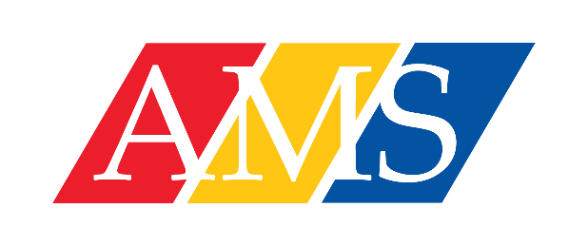Chair of the AMS Board of Directors

**Report to Assembly**

**Dreyden George**

[**board.chair@ams.queensu.ca**](mailto:board.chair@ams.queensu.ca)

Hello Assembly!

I hope everyone enjoyed the end of their summer and has had a successful start to what is some of the busiest times of the year for student governance and services. The Board this past month has seen no urgent or major problems presented to the organization and have been able to maintain accomplishments as set in our committee goal plans and timelines. We also will be having for early October a completed updated Board page on the website that is currently under Governance to ensure it is accurate and reflects current compositions.

*Board Meeting:*

The last board meeting (August 27) went well with only finding a slight delay to ensure quorum, this meeting approved the consolidated operations budget, the by-law recommendation for the AGM this December around the name change of Tri-colour to Society 58’, approval of the LS Retail Project Phase 2: for the Common Ground Coffee House and the Brew, this is following also approval of the allocation for completing the Phase 1 for Retail implementation at Queen’s Pub, this is a super exciting investment for the organization ensuring to avoid future risk while also being proactive in improving student services. We also approved at Board the Publishable Copy of the AMS 3 Year Strategic Plan approved from May 2025, and reviewed the One Pager for internal management assistance, as well the Fall Governance Calendar outlining all Board meeting, committee meetings, and the AGM (December 2) to be held throughout the Fall semester. Last but not least the Chair prepared a Summer Semester Recap outlining all progress made, challenges encountered, and general metrics that have shown to universally improve across the board compared to previous year. If anyone has any questions or inquiries about our board meetings, or requests of session minutes, feel free to reach out to myself, the secretariat, or the Vice-Chair of the Board Eshal Ali ([board.vicechair@ams.queensu.ca](mailto:board.vicechair@ams.queensu.ca)).

*Committees*:

This month for committees we have operated as per compliance of our Board policy manual, the Finance and Risk Committee, Personnel Committee, Governance Committee, and Strategic Planning Committee meetings which have met now two – five times and worked on their years projects.

Personnel has continued to work on HR Policies for review, develop the restructuring manual, and held the first Student Director Honorarium Review committee, that is an ad-hoc establishment under Personnel and is a requirement from the By-Laws.

The F&R Committee has completed first draft for second reading in committee of the Risk Management Framework Procedure as required for review. Further the GM is in process of completing Risk Investigations for the year, with completion of all other permanent staff risk investigations, and reviewed at the September committee meeting.

The Governance Committee has delivered the SAF Review Brief to the Chair of the SAF Review Committee and is looking forward to seeing the progress made on this year's committee and is thankful for their work. Further the Governance committee reviewed professional development planning updates and completion from the Chair and Vice-Chair, with engagement updates also provided. The governance committee began discussing the plan for Board evaluations this year. With also having the Information Records Policy up for its standard review led by our Information Officer, the Board Policy Manual will being work on for review by the Chair and other board members for reviewal completion.

The Strategic Planning Committee continues to work on as established in August committee to work towards the implementation layout and system establishment of KPI’s for the 2026-2027 Year and have been receiving updates from the GM on Strategic Plan implementation and timelines. This coming semester is discussed to work on the planned capital project framework for helping address concerns from stakeholders and students on large capital/special project planning, development, management/oversight, with transparency and monitoring systems. The Chair of the Committee and VPUA also have been beginning the HOUSE project assessment and analysis with discussions with them and the KHSC.

For other committees, the Annual Report Editorial Board has met twice and reviewed the first draft with summaries complete awaiting financial statements. The JAB we are awaiting communications on start dates for our delegate the Vice-Chair. As well the Chair is ready for sitting on the ad-hoc SAF Review Committee.

*Pro-D for Board:*

We have held the PI session to help improve team collaboration and productive discussions and oversight, we also have had all student directors complete the Board Essentials 101 Modules, and have had the Strategic Planning Committee complete the KPI Modules training ahead of the work coming forward for KPI developments and establishment. We also have coming up is the F&R Committee professional development where they will be attending an online seminar held by the CPA, and also having the Startegic Planning committee complete a Services and Programs Planning Session, where there is an engagement piece with the assembly where the survey sent out will be crucial in the training provider helping outlining current needs, gaps etc.

If you have any questions, concerns, or something to discuss about board I am always open to meeting or happy to reply to an email. Have a great start to the Fall season.

All the Best,

**Dreyden George**

Chair of the Board of Directors | Alma Mater Society

[**www.myAMS.org**](https://can01.safelinks.protection.outlook.com/?url=http%3A%2F%2Fwww.myams.org%2F&data=05%7C01%7Cboard.chair%40ams.queensu.ca%7C99a9aa8ae5bd49d147dd08dab3df5a40%7C12b332a2f36f4f8ea4aa8762f4c65952%7C1%7C0%7C638020069123142308%7CUnknown%7CTWFpbGZsb3d8eyJWIjoiMC4wLjAwMDAiLCJQIjoiV2luMzIiLCJBTiI6Ik1haWwiLCJXVCI6Mn0%3D%7C3000%7C%7C%7C&sdata=elqN%2FuUA%2ByYjJexj2VjC%2F%2F8f%2FgS7qftd4zmc%2B1%2FzTu0%3D&reserved=0) | [**@queens_ams**](https://can01.safelinks.protection.outlook.com/?url=http%3A%2F%2Fwww.myams.org%2F&data=05%7C01%7Cboard.chair%40ams.queensu.ca%7C99a9aa8ae5bd49d147dd08dab3df5a40%7C12b332a2f36f4f8ea4aa8762f4c65952%7C1%7C0%7C638020069123142308%7CUnknown%7CTWFpbGZsb3d8eyJWIjoiMC4wLjAwMDAiLCJQIjoiV2luMzIiLCJBTiI6Ik1haWwiLCJXVCI6Mn0%3D%7C3000%7C%7C%7C&sdata=elqN%2FuUA%2ByYjJexj2VjC%2F%2F8f%2FgS7qftd4zmc%2B1%2FzTu0%3D&reserved=0)

Alma Mater Society | Queen's University

JDUC

*The Alma Mater Society acknowledge that Queen’s University is situated on traditional and current Anishinaabe and Haudenosaunee territory, which we are an uninvited guest on. Katarokwi is abundant in history and modern-day traditions of many First Nations and Métis peoples. It was within the Crawford Purchase (1783) that these lands were made available for settlement. The agreements made were upheld by the First Peoples, but not by the British Crown or later Canadian government. While we work on these lands as uninvited guests, we actively benefit from the oppression of Indigenous peoples. These lands surrounding the Great Lakes are immersed in thousands of generations of Indigenous history, including language, art, celebrations, and resilience*

**All the Best,**

**Dreyden George**

**Chair of the Board of Directors | Alma Mater Society**

[**www.myAMS.org**](https://can01.safelinks.protection.outlook.com/?url=http%3A%2F%2Fwww.myams.org%2F&data=05%7C01%7Cboard.chair%40ams.queensu.ca%7C99a9aa8ae5bd49d147dd08dab3df5a40%7C12b332a2f36f4f8ea4aa8762f4c65952%7C1%7C0%7C638020069123142308%7CUnknown%7CTWFpbGZsb3d8eyJWIjoiMC4wLjAwMDAiLCJQIjoiV2luMzIiLCJBTiI6Ik1haWwiLCJXVCI6Mn0%3D%7C3000%7C%7C%7C&sdata=elqN%2FuUA%2ByYjJexj2VjC%2F%2F8f%2FgS7qftd4zmc%2B1%2FzTu0%3D&reserved=0)**|**[**@queens_ams**](https://can01.safelinks.protection.outlook.com/?url=http%3A%2F%2Fwww.myams.org%2F&data=05%7C01%7Cboard.chair%40ams.queensu.ca%7C99a9aa8ae5bd49d147dd08dab3df5a40%7C12b332a2f36f4f8ea4aa8762f4c65952%7C1%7C0%7C638020069123142308%7CUnknown%7CTWFpbGZsb3d8eyJWIjoiMC4wLjAwMDAiLCJQIjoiV2luMzIiLCJBTiI6Ik1haWwiLCJXVCI6Mn0%3D%7C3000%7C%7C%7C&sdata=elqN%2FuUA%2ByYjJexj2VjC%2F%2F8f%2FgS7qftd4zmc%2B1%2FzTu0%3D&reserved=0)

**Alma Mater Society | Queen's University**

**JDUC**

***The Alma Mater Society acknowledge that Queen’s University is situated on traditional and current Anishinaabe and Haudenosaunee territory, which we are an uninvited guest on. Katarokwi is abundant in history and modern-day traditions of many First Nations and Métis peoples. It was within the Crawford Purchase (1783) that these lands were made available for settlement. The agreements made were upheld by the First Peoples, but not by the British Crown or later Canadian government. While we work on these lands as uninvited guests, we actively benefit from the oppression of Indigenous peoples. These lands surrounding the Great Lakes are immersed in thousands of generations of Indigenous history, including language, art, celebrations, and resilience***

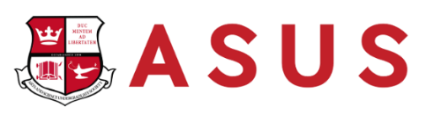Arts & Science Undergraduate Society

**President’s Report to Assembly**

**Ivana Drinziu**

[**president@asus.queensu.ca**](mailto:president@asus.queensu.ca)

Engineering Society

**President’s Report to Assembly**

**Jordan Belainsky**

[**president@engsoc.queensu.ca**](mailto:president@engsoc.queensu.ca)

Hello Assembly!

It’s so exciting to have everybody back on campus because that means we are in full service for the year! Here are some highlights below:

**Orientation Week:** We had a record number of first year registrants as well as an amazing week of events. The weather was beautiful the vibes were amazing so shout out to FC for organizing an amazing Orientation!

* For anyone in Engineering interested in planning O-Week, Orientation Chair (OC) applications are now open on breezy! You must be 2nd year engineering or older to apply and be returning to classes in 2026.

**Bank of EngSoc (BoE):** Director of Finance (DoF) and the financial officers (FO’s) are back in person, so we are fully operational! Purchasing and reimburments for affiliated groups are now open for processing!

**First Year Exec:** Elections for Sci ‘29 Year Exec will be happening Wednesday 17th in Stirling Hall. If you have any questions or are interested in running reach out to our Director of First Year Stephie (firstyear@engsoc.queensu.ca).

**Services:** Everything is up and operating! Hungry? Grab a bagel from the Tea Room! Trivia? Check out the Clark social media for events! From CEO, EngLinks, iCons, and Golden Words we’re open! Science Quest manager opportunities will be opening up later this year so keep an eye out if you are interested in operating out summer camp!

**Operational Budget:** Now that O-Week is over our Exec will be putting final touches on our operational budget to be approved at second council.

**Hiring, Hiring, Hiring!:** Want to be involved? Check out breezy! So many applications across our society are going to be available over the next month so make sure you keep an eye out on our Instagram or within the All Eng newsletter for those opportunities!

If you have any questions about what we’ve been up to, don’t hesitate to reach out!

**Engineering Society Executive**

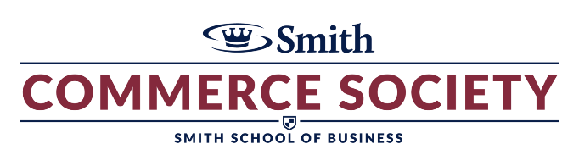Smith Commerce Society

**President’s Report to Assembly**

**Prem Mehta Spooner**

[**president@comsoc.queensu.ca**](mailto:president@comsoc.queensu.ca)

This September, ComSoc had the opportunity to engage with over 500 first-year students in the Commerce program through our WelCOMMing initiatives and a networking event in Grant Hall. It was energizing to see the enthusiasm of the incoming class, and as our demographics continue to shift, we are actively considering how this will impact our operations in the year ahead. I want to highlight the tremendous work of Ali, our CEO Chair, who played an instrumental role in supporting these efforts, as well as the ORT Roundtable for their ongoing collaboration.

Over the summer, ComSoc invested $14,000 into revitalizing the ComSoc Shop, our platform that manages both events and hiring processes. This upgrade has modernized the system after eight years and successfully onboarded core functionalities, making it an integral tool for our community. While we have explored potential integration with Bounce, significant challenges remain, and we believe a more effective solution would be to centralize event sanctioning through ComSoc Shop with AMS oversight.

Alongside this, we have launched asynchronous workshops for our co-chairs to build knowledge in event sanctioning, ComSoc Shop use, finances, and equity, diversity, inclusion, and indigeneity, ensuring our leaders are better equipped to succeed.

Looking ahead, our first ComSoc Assembly is scheduled for September 21st, with elections currently underway for our elected members, including the two AMS Representatives, which will conclude on September 22nd. ComSoc remains committed to advancing continuity, credibility, and community as we begin the year and to working closely with AMS to improve processes and strengthen student advocacy.

Sincerely,

Prem Mehta-Spooner

President, Smith Commerce Society

Health Sciences Society

**President’s Report to Assembly**

**Arani Hiritharan**

[**president@hss.queensu.ca**](mailto:president@hss.queensu.ca)

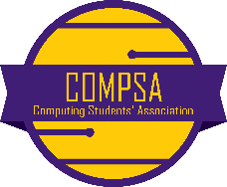Computing Students’ Association

**President’s Report to Assembly**

**Hugh Tuckwell**

[**president@compsa.queensu.ca**](mailto:president@compsa.queensu.ca)

Dear Assembly,

Good to be back! We hope everyone is doing well and thoroughly enjoying the start of the fall semester. We have a ton of updates to get through on all fronts of our portfolios:

**Fall Hiring |** Fall Hiring drops today! We’re hiring for 1 intern across all of our 12 portfolios as well as 6 executive interns (2 per exec), the most COMPSA has ever hired for! We’ve gotten tons of awesome feedback and interest from first years in O-Week, and we are proud of the growth COMPSA has enjoyed over the past few years. Can’t wait to see what’s next!

**Executive |** As executives, we’ve been pretty busy beyond Fall Hiring. We’ve obviously started up leading our assorted portfolios on their various projects & events (which I’ll get into in more detail later), but we’ve also been trying to expand our CCR (COMPSA Club Roundtable) by redo-ing our contracts to make them more fair & generous to Computing-adjacent clubs, as well as reaching out to more clubs who could benefit from the CCR. When we officially launch the CCR in the next couple of weeks, we anticipate the roundtable to have ~12 clubs! We’ve also decided to partner with the newly-founded AI Collective in Kingston for an upcoming keynote & expert’s panel

**Portfolios |** All of our portfolios have been super busy! Academics has been busy starting up their coffee chat series, starting to find interest for tutors for exam tutorials & revamping our first year guide after the recent SoC changes to Computing Courses. Athletics have their events on lock for this year & are looking forward to implementing the soccer/basketball intramurals + tournaments that were very popular last year. EDII has been working on their Welcome Home Night with QWIC & QBCS, as well as planning various other equity-focused events & activities. Events are planning a cruise right now, and decided on a tropical theme :) . They’re also starting to think about Fall Night Out venues & starting to plan for it (Likely Tett Centre again yay!). Finance, Socials, & Marketing have been keeping everything steady, on-time, active & on-budget. IA has been focused on adding some quality-of-life improvements to our Computing Commons as well as doing some Cas-Connect stuff (Zain the GOAT). Our Industry Outreach director has been MIA for some time and we were about to start the look for a replacement today, but he miraculously appeared and is now just getting started on running the portfolio. Merch is planning their first drop later this semester & gave out a TON of COMPSA Lanyards during O-Week, and they were very popular. Our Tech Team has also been crazy efficient, implementing a Caslab Booking System as well as building an AI chatbot to answer FAQS and generally keeping everything running smoothly.

That’s all from us for now—stay cool and enjoy the start of the fall semester!

Concurrent Education Students’ Association

**President’s Report to Assembly**

**Emily Gluckman**

[**president@cesa.queensu.ca**](mailto:president@cesa.queensu.ca)

Hello Assembly!

**Orientation**

CESA had an absolute blast at ConEd Orientation events these past two weekends! It has been so amazing seeing the amazing team of teaches welcome over 350 incoming students with such warmth, enthusiasm, and ConEd love. Ellie, and the entirety of Teach Exec worked so hard to help mentor our teaches and put on such amazing events and set up support systems for years to come!

**Events**

We have a few exciting events coming up! Our annual buddy picnic is scheduled for Sept. 23rd. Our 2nd year reps have been working hard to invite first-years and upper-years to set up friendships and help introduce our first-year students to Queens and ConEd! Our dates for ConEd camp are set for Nov. 8-9 weekend! We are getting SUPER excited! QCE (Queen’s Conference on Education) is booked for January 24-25 weekend! And we have more activities on the way!

**Hiring & Elections**

We are electing 5 and hiring 13 positions during our fall hiring/elections! We are super excited to get the ball rolling and hopefully have not one, but two AMS representatives (one general, one first-year) to join me at these meetings by our next Assembly! TBD!

SO happy to be here in person, lots of ConEd love! Feel free to reach out if you have any questions or just want to chat!

**Emily Gluckman** (she/her)

CESA President

[president@cesa.queensu.ca](mailto:president@cesa.queensu.ca)

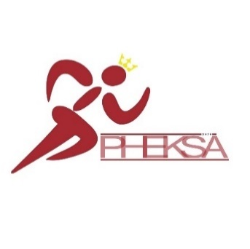Physical Education & Kinesiology Students’ Association

**President’s Report to Assembly**

**Cynthia Charette**

[**president@pheksa.queensu.ca**](mailto:president@pheksa.queensu.ca)

To Assembly,

I hope your first week of class has gone well and you are settling into your courses and semester well.

We had our first official PHEKSA assembly meeting this week and were very excited to introduce our new members to our expectations and procedures.

We finished off orientation week this past weekend, and it was amazing. It is always so nice to see the first years come out of their shells and welcome them to our program. We are super excited to see where they go and how they integrate themselves into Kinesiology.

As for our empty assembly positions, we are opening elections and hiring applications this week and will continue with our election period and interviews. After that, we hope to have our full assembly in motion.

At this time, PHEKSA does not have any motions we wish to propose to the group.

See you next week!

Cheers,

**Cynthia Charette** (she/her)

PHEKSA President

president@pheksa.queensu.ca

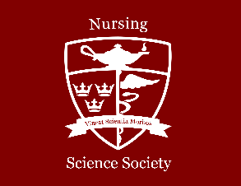Nursing Science Society

**President’s Report to Assembly**

**Mika Heler**

[**president@nss.queensu.ca**](mailto:president@nss.queensu.ca)

Hi everyone,

I hope you all had a wonderful summer break and are excited to get back into things. Here are my updates from the last few months:

**NOC x NSS Collaboration**

During orientation, the NSS participated in an academic event hosted by the NOC. During this event, we had the opportunity to introduce the NSS and highlight the roles and responsibilities of our members.

**Class Councils**

We’ve been working internally to organize the upcoming class council elections for the fall semester. This includes elections for Year 1, Year 3, and AST3 cohorts.

**Intern Projects**

The executive team has been brainstorming intern projects for this year. One idea currently under consideration is the revival of the textbook library in the School of Nursing

**Best,**

**Mika Heler**

She/her [(Click here to learn about pronouns)](https://www.mypronouns.org/what-and-why)

NSS President

Nursing Science Society | Queen's University

Email: president@nss.queensu.ca

Kingston, ON

*I acknowledge and honour that Queen's University is situated on traditional Anishinaabe and Haudenosaunee Territory. I invite you to join me on a continual reflection regarding the history of the land on which we learn, work, play, and reside.*

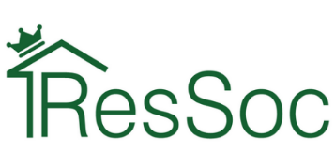Residence Society President & CEO

**Report to Assembly**

**John Bae**

[**president@ressoc.queensu.ca**](mailto:president@ressoc.queensu.ca)

Hello Assembly,

Since my last report, ResSoc has assisted nearly 5,000 students moving into Queen’s Residences this year.

In the first two weeks of September, ResSoc delivered large-scale programming, supporting residence students in their transition to campus life, and ensuring student advocacy remains central as residence communities take shape.

August student-staff training was a success. Despite some transportation delays due to Air Canada’s recent strike, we were able to quickly develop a hybrid model with accompanying training-competency assessments to accommodate these folk.

All 19 House Presidents are fully placed in their communities and are in the process of developing Fall semester programming as well as unique ways to involve residence students in meaningful work, such as through House Council. Our VPRO and VPSO have been hard at work overseeing and improving residence and society operations such as approving Fall programming, and our PMO recently delivered hugely successful large-scale programming with early move-in, Welcome Home Night, and orientation activities. And finally, work is also underway to streamline administrative systems such as financial tracking and HR processes.

In terms of current and ongoing priorities, ResSoc is aiming to develop more engaging methods of student outreach. One initiative we are piloting this fall is the creation of monthly House Council themes that align with Housing & Ancillary Services committee themes. This approach will help us build a clearer bridge between the conversations happening at the governance level (e.g., dining, accessibility, residence operations) and the day-to-day experiences of students in their communities. By coordinating themes, House Presidents can create structured spaces to gather student feedback on specific issues that directly inform committee discussions. For example, when H&A committees discuss dining, House Councils can run surveys or host socials around food services, then funnel insights directly to ResSoc representatives. Improved student outreach directly supports ResSoc’s broader priorities of: policy development (using consistent student input to shape SOPs), advocacy (amplifying residence student voices on institutional decisions), and engagement (making councils more purposeful and connected to residence-wide issues).

The first month of the academic year has been busy, productive, and filled with collaboration. ResSoc remains committed to ensuring that residence students have not only a safe place to live, but also a vibrant community in which to thrive. We look forward to working with you all to deliver an amazing experience to Queen’s Residence students.

Best regards,

**John Bae** *(he/him)*

President & CEO | president@ressoc.queensu.ca

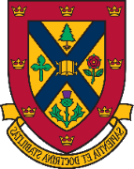Undergraduate Student Trustee

**Report to Assembly**

**EJ Kelvin**

[**trustee@ams.queensu.ca**](mailto:trustee@ams.queensu.ca)

Dear Assembly members,

I hope you’re all doing well and settling into the new school year! My name is EJ and I began my term as Undergraduate Student Trustee in June, and it’s wonderful to have the full Assembly together now that the school year has started. I’m excited to work with you this year.

Our Board meeting later this month is coming up, if there’s anything you’d like me to raise, or if you have questions or concerns, please reach out. I’m always happy to listen and help, and I’ll report back at our next Assembly.

Best wishes,

EJ Kelvin (she/her)  
Undergraduate Student Trustee ’25–’27

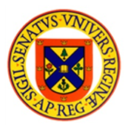Student Senate Caucus Chair

**Report to Assembly**

**Sakura Koner**

[**sscc@ams.queensu.ca**](mailto:sscc@ams.queensu.ca)

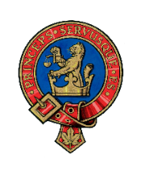Office of the Rector

**Report to Assembly**

**Niki Boytchuk-Hale**

[**rector@queensu.ca**](mailto:rector@queensu.ca)

Hello Presidents,

Happy new year! I hope you’re also finding that the commotion on campus is energizing, especially in the new JDUC. And welcome to all the new faces! If you’re wondering what a grad student is doing at the undergrad governing body, I’ll point you to these two videos – an [**introduction**](https://www.youtube.com/watch?v=c72azivlD3I&feature=youtu.be)to me and [**Rector duties**](https://www.youtube.com/watch?v=qQEUJRTao4E).

I’d like to highlight that the National Day for Truth and Reconciliation (NDTR) is coming up on September 30. More information can be found [here](https://www.queensu.ca/indigenous/truth-and-reconciliation/2025-events-and-initiatives) about ways you can spend this day engaging in learning and reflection. This year, Edward the AMS Social Issues Commissioner, and I are developing a heart garden for two locations on campus. This garden is a way of visually displaying the number of residential schools that were once active in Ontario, acknowledging the lasting impact, and showing care for families and survivors. Thank you to everyone who came out last week to paint the hearts orange.

**Office |** I have recently hired a new Multimedia Producer to support with our photo and video projects for this academic year! I have also hired a Student Leader Development Conference (SLDC) Project Officerwho was our first-year intern last year, to help support the planning and organizing of SLDC 2025. Soon, the office will be opening up hiring for our first-year intern. We are excited for the team to grow!

**Community Engagement |** It’s no surprise that orientation has been the biggest event in the books. I have been yet again so impressed with the hundreds of leaders involved in making this possible for incoming students. So far, I’ve found myself speaking and enjoying ORT leader training, ASUS welcome forum, Tricolour Open House, and the football game. As you plan for your events this semester, you’re welcome to send us a note about it so we can hopefully attend!

**Board of Trustees**| I have no updates, other than the Board and its committee will be meeting during the last week of September.

The Board has regular Open Session meetings four times per year, and community members can request to join in-person or online by sending an email to [**trustees@queensu.ca**.](mailto:trustees@ams.queensu.ca) Anyone can also access the[**Governance Portal**](https://queensuniversity.civicweb.net/Portal/)to view the agenda by clicking on the calendar date of the meeting.

**Committees |** While most committee work dials down during the summer, there were three that persisted.

* **Tricolour Award Selection Review:** We have completed this committee and have recorded changes to the Tricolour Award selection terms of reference. This will be released at the end of this month.
* **Rector Election Policy Review:** the committee has made a great deal of progress and edits to clarify and update important parts of the policy. AMS Assembly and SGPS Council can expect to see the proposed changes for final approval by November.
* **National Day for Truth and Reconciliation Working Group:** Thank you to everyone for participating in our drop-in painting for the NDTR Heart Garden.

**Rector’s Digest |** This month, I discussed the [**impact of rankings**](https://www.queensjournal.ca/158026-2/), and how I personally did not look at any of the rankings when applying to university, but they remain a very important factor globally. While an undergraduate degree isn’t the ticket to ride like it used to be, I’d say the opportunity is about the experiences and relationships formed inside and outside of the classroom. The real test of a university is how it shows up for its current students. If we’re going to be number one in anything, let it be making sure no one goes hungry here and that every student feels like they belong. That’s a ranking I’d put some weight on.

That’s all for now! Please reach out to me if you have any questions, need support, or would like to share an experience that can help me convey student voices to the administration. If you’d like to book a meeting or send an event invitation, please contact [rector.assist@queensu.ca](mailto:rector.assist@queensu.ca)

At your service,

, Picture, Picture

**Niki Boytchuk-Hale** (she/her)

**University Rector**  
Office of the Rector

*Princeps Servusque Es (Be a Leader and a Servant)*  
  
T 613-533-2733  
[**rector@queensu.ca**](mailto:rector@queensu.ca)|[**queensu.ca/rector**](https://queensu.ca/rector)Picture 16, Picture, Picture    Picture 15, Picture, Picture    Picture 14, Picture, Picture    Picture