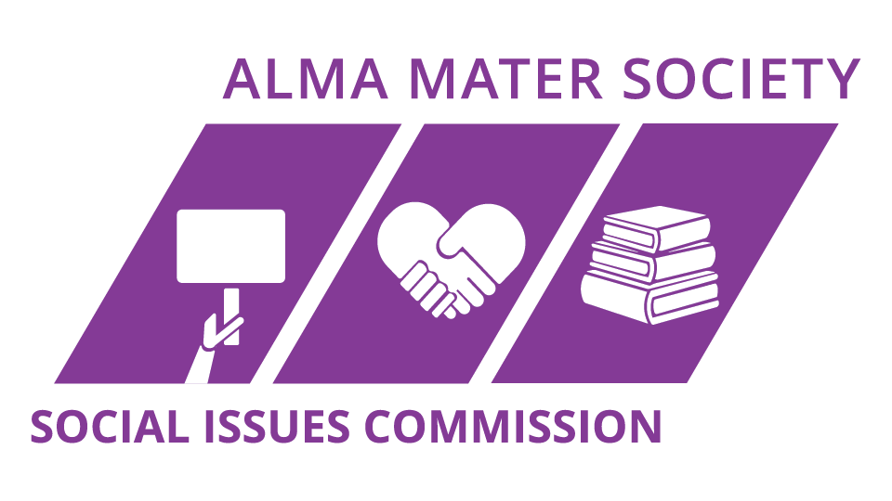
THE SOCIAL ISSUES COMMISSION EVENT CERTIFICATES PROGRAM (SICEC)

From the AMS Social Issues Commission

Queen’s University

TABLE OF CONTENTS

Partners…………………………………………………………………...3
Introduction……………………………………………………………….4
Incentives………………………………………………………………….5
SICEC Description……………………………………………………….6
The SICEC’s…………………………………………………………….13
Conclusion……………………………………………………………….14

INTRODUCTION

Welcome to the SIC Event Certificates

The SIC Event Certifications (SICEC) is a campus initiative founded by the Social Issues Commission and the Alma Mater Society.

The SICEC is designed to educate and assist students in improving social responsibility and/or activism associated with their events/programs. Throughout the SICEC, you will be guided through a variety of event planning options to improve in the following areas to be certified: The Accessibility and Neurodiversity Certificate (ANC), The Indigeneity and Reconciliation Certificate (IRC), and The Diversity and Inclusivity Certificate (DIC). If these three are established, you will receive the golden certificate for Equity Event Certificate (EEC).

We hope that everyone uses the SICEC as an opportunity to be creative and explore equitable alternatives or additions in your project planning.

If you have any questions or need assistance in any process or clarification, please reach out to the Social Issues Commissioner External (sic.external@ams.queensu.ca). Have Fun!

Link for the sheet to fill out for your application submission alongside a project/event plan/summary

SICEC Evaluation Sheet.xlsx

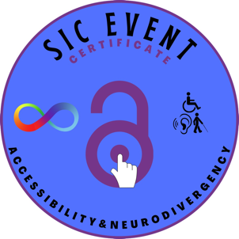
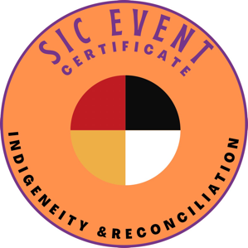
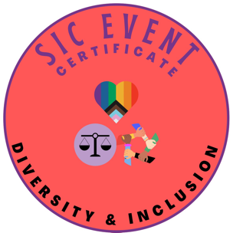
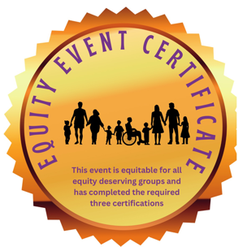

INCENTIVES

While we hope the SICEC inspires you to take initiative and improve equitable impact of your event, there are also extremely exciting rewards if your event’s awarded the one of the SICEC or the Gold EEC.

- Recognition as an event that achieved the ANC, IRC, DIC, or EEC at Queen’s University including certificate stamp and promo to add to event.

- A 10% discount for each certificate received for the SLC. (Equity Event Certificate Status means you will receive 30% off!

- Social Media promotion through the SIC, AMS, DNA (ANC & EEC Only), Four Directions (IRC & EEC Only), and other Equity Channels (Instagrams/Facebook, Newsletters, Websites, Calendars).

- Eligible for grants, funds, and awards through applying to the applications below, mentioning the certificates as an apart of your events can possibly improve your chances.
(…) = limitations to eligibility
- Event of the Year (Event is ran by club and sanctioned through AMS)
- Club of the Year (Event(s) is/are ran by club sanctioned by the AMS)
https://www.myams.org/clubs/club-awards/
- Clubs Experience Grant (Event(s) is/are run by club sanctioned by the AMS)
https://www.myams.org/clubs/club-grants-bursaries/
- AQ Grant (Only ones that are achieving ANC or EEC, that have costs incurred from expenses made to increase accessibility/neurodivergence accommodations)
- Equity Grant (For events that achieve any certificate but centers event on community outreach, educational campaigns, and/or awareness/advocacy projects.
https://www.myams.org/about/my-ams/ams-grants-bursaries/
- Student Initiative Fund
https://www.queensu.ca/studentaffairs/funding-awards/student-initiative
- Inclusive Community Fund (for events that centre EDII-AN values)
https://www.queensu.ca/inclusive/initiatives/inclusive-community-fund

- Entry into the Equitable Event of the Year Award (If all three certificates achieved, and received Equity Event Certificate), where a draw of the events who achieved this receive an award of 250$. This is drawn semesterly. Entry of the draw is limited to one entry per event for that semester (events that run multiple times over the semester receives one entry for each semester).

SICEC DESCRIPTION

The SIC Event Certificates is designed as a checklist that student planners can use while organizing events. Simply work your way through the SICEC and check off the equity-based alternatives/additions that your event utilized to improve its EDII-AN impact. As well attach the project plan/summary

To apply for the SICEC, simply follow the instructions below and on the appropriate excel sheet (hover over the cells with red triangle to view instructional notes), list the certificate criteria your event is planning on meeting, and upload documentation where appropriate. Then, email your SICEC application form as an excel file the Social Issues Commissioner External (sic.external@ams.queensu.ca) with the relevant evidence attached as a single word document. The SIC will assess your submitted sheet and event plan/summary and assess the applicable points to the event and consider the points earned entered through the sheet to calculate the percentage of completion of the total criteria.

A full description of the SICEC and its components is in this document. The SICEC application is a onetime use per event.

Point Assessment

The SICEC are based on a points system. Application will grant points based on the equity-based alternatives/addition used during your event. A full breakdown of points granted for each alternative/addition is in this document and the SICEC Application form.

To obtain the Standard SICEC, events must achieve a minimum of 75% of the points applicable for each certificate.

In addition, if these minimum points are achieved in all certificate categories, your event is eligible for EEC (Equity Event Certificate), the gold certificate. This is earned by earning all three certificates’ criteria.

Uploading Documentation

When applying for the SICEC, the form will have multiple sections which require documentation or another form of proof. This is to ensure accountability when applying for the SICEC.
Include the relevant documentation as evidence/proof in the form of a single, compiled word document in the email along with the completed SICEC form.

Additionally, there are opportunities to provide a description on how your team included equitable alternatives/additions throughout the event within the Action Plan column. These sections are in place to create institutional memory within the Social Issues Commission of equitably conscious alternatives that student groups are implementing across campus. We are extremely excited to see the initiatives that are created by the amazing student leaders at Queen’s University!

Awarding the SICEC

The Social Issues Commissioner External will assess your application once it has been submitted via email. If your event achieves the minimum number of points or more, you will be contacted via email about the success of your application!

Once your event is approved through the SIC, you will be required to advertise your SICEC status during your event and to your attendees. This is to help increase the visibility of the SICEC and encourage other leaders to use the SICEC as a resource to improve the equitable impact of their event! You will also receive SICEC logos, to assist with marketing your event SICEC Certified.

Discount Application Process

Student Life Centre:

Upon approval from the SIC External, you will receive in the same congratulations email awarding the certificate, marketing materials, and next steps; you will be given a discount for the amount awarded (1 certificate = 10%, 2 certificate = 20%, 3 certificates = 30%) to apply at checkout for a one-time purchase per event.

Timeline

To provide ample time for the assessment of the SICEC and application of discounts, please submit your SICEC application a minimum of 2 weeks before the event is scheduled to take place.

THE SIC EVENT CERTIFICATES

You are more than welcome to use this portion of the SICEC to help guide your event planning process and then fill out this form after the events fully organized.

Points assigned based on the options you select.

To obtain the specific SICEC, events must achieve a minimum of 75% of points available for that specific certificate. Below is a list of the criteria with a brief description to aid in your event planning.

Equitable alternatives/additions that require proof will have an option to upload the required documentation. Unless arrangements made.
in advance, points will not count for items requiring proof if no documentation uploaded. Please contact the Social Issues Commissioner External (sic.external@ams.queensu.ca). if you have any questions!

FOOD AND BEVERAGES (if Applicable)

The Accessibility and Neurodiversity Certificate (ANC)

- Food/Beverage clearly labelled - 1.5 pt.
- Food/Beverage and Information labelled with Braille - 1 pt.
- Utensils/Dishware have accessible accommodations upon request – 1 pt.
- Food/Beverage facilitated by someone to assist or guide someone for food/beverages – 2 pt.
- Provide accommodation request/options (no allergen, vegetarian, vegan etc.) and label any allergens or dietary restrictions with each food – 2 pt.
- Food/Beverage seating and display tables are no taller than three feet and is in an accessible area – 1.5 pt.
- Provide volunteers, presenters, staff, and organizers etc. with accessible and neurodivergent training for service, assistance, accommodation, and solidarity. – 2 pt.

The Indigeneity and Reconciliation Certificate (IRC)

- Uses Indigenous owned food/beverage suppliers – 1 pt.
- Organize an elder to bless the food before the event – 1 pt.
- Serves Indigenous traditional food/beverages made by Indigenous people - 1 pt.

The Diversity and Inclusivity Certificate (DIC)

- Provide option for religious or other Dietary accommodation (Halal, Kosher, etc.) – 1.5 pt.
- Include food/beverage for free or offer a financial aid option – 1 pt.
- Serves food/beverages made from businesses owned by equitable deserving groups - 1 pt.

VENUE FEATURES AND LOCATION

The Accessibility and Neurodiversity Certificate (ANC)

- Ensure that the route to the location is accessible. Consider any construction barricades along Queen’s and city routes. – 2 pt.
- Contact Queen’s Facilities/PPS for snow and ice removal. (If applicable) – 2 pt.
- Accessible parking nearby? Contact the Parking Office to arrange temporary parking if necessary. – 2 pt.
- Attendees provided clear and accurate map of campus and venue for location, with directions or location descriptors for assistance – 1 pt.
- All accessibility features are operational, e.g., doors, elevators, lifts, etc. If not,
contact PPS/FixIt. Public elevators can accommodate wheelchairs and motorized scooters. - 2 pt.
- Elevators have raised/braille buttons for persons who have low vision or are blind. Has auditory signals for persons who have low vision or are blind. - 2 pt.
- Know the location of accessible washrooms. Accessible washrooms are near meeting location. Are washrooms and stalls large enough to accommodate scooters and wheelchairs? – 2 pt.
- Venue Allow for easy movement for wheelchair, scooter, and service animals (You may rearrange furniture). Are the venues hallways/aisles (one meter width) and doorway wide enough for wheelchairs and scooters? – 2 pt.
- Include accessible areas interspersed throughout the room – front, middle and back. - 1 pt.
- A lot of space around tables. - 1 pt.
- Good lighting (bright, without glare and allows for adjustment). Good acoustics (Background noise is not excessive.) - 1 pt.
- If a stage used, it is easily visible and persons using a mobility aid can access the
stage safely. (If applicable) – 1 pt.
- Projector screen is easily visible. (If applicable) – 1 pt.
- Provides reserved seating for people who are Deaf, deafened, or hard of hearing.
people. – 1 pt.
- Space for sign language interpretation and/or simultaneous interpreter service – 0.5 pt.
providers
- Cover electrical cables or cords that cross over aisles or pathways so wheelchair.
users as well as people who use canes and walkers can traverse safely across them. – 0.5 pt.
- Venue has a private space for people to go to take a break. 1 pt. +

The Indigeneity and Reconciliation Certificate (IRC)

- Venue owners and venue itself support reconciliation of Indigenous Peoples 2 pt.
- Venue contains Indigenous art, music, infrastructure etc. made by Indigenous peoples 2 pt.
The Diversity and Inclusivity Certificate (DIC)

- Designated quiet area for reflection, meditation and/or multi-faith prayer. 1 pt.
- Secluded, comfortable location for breastfeeding. 1 pt.
- Gender neutral washrooms available 2 pt.

EVENT FEATURES AND PROMOTION

The Accessibility and Neurodiversity Certificate (ANC)

- Give option for Assistive learning devices (contact event services) – 1 pt.
- Interpretation services are available in the following formats: • American Sign Language (ASL) • Deaf blind intervener services • Oral interpreters for a person who is hearing impaired and may not use sign language and may rely on speech (lip) reading (Communication Access Real-time Translation (CART)) – 1 pt.
[ to identify the needs for your event, include in the promotion a statement, requesting attendees who need these accommodations to give notice and request them through a designated contact and tentatively book an ASL interpreter until confirmation of need of the accommodation. Communicate a date in which requests are due by participants (e.g., ASL interpretation is not requested you can cancel without penalty).]
- Your event notice state that support persons will not be charged for admission or registration, but a small or reduced fee will be charged for food or meals consumed.
having volunteers to assist any service animals with food/water and bio breaks. Provide bowls for water for any service animal. – 1 pt.
- Volunteers are available and clearly identifiable. – 1 pt.
- Evacuation route is accessible. – 2 pt.
- Use inclusive language, e.g., person with a disability. 1 pt.
- Promote a scent-free environment – 1 pt.
- Give ample notice (at least 2-3 weeks) for your upcoming event – this allows people to arrange for transportation, assistants, or other supports they may require. 1 pt.
- Is all online information, registration forms, emails, social media posts, websites, and materials accessible? Tutorials | Accessibility Hub (queensu.ca) - 3 pt.
- Describe in detail any physical activities in promotion – 1 pt.
- Staff and volunteers are aware of who requested any materials in an accessible format and any dietary requirements. If anyone requested materials for the event in alternate formats, have them at the registration desk to hand out – 1 pt.
- Create signs with large print and contrasting colors to identify and give directions to meeting rooms, washrooms, and emergency exits. Participant nameplates and ID tags also should be easy to read. – 1 pt.
- Circulate meeting materials and presentations at least one week prior to the meeting. One week is the minimum time required for participants to review or convert materials to alternative formats. Alternate formats available: • Documents written in plain language. • Printed material available in Braille, large print, audio format on CD or DVD (as required). Videotape presentations accessible through use of descriptive narration and/or captioning. Ensure any PowerPoint presentations are accessible. For example: • Font size for text documents should be a minimum of twelve points. Font size for presentation slides should be a minimum of sixteen points. • Use sans-serif fonts such as Arial, Tahoma, or Geneva. - 2 pt.
- Describe any visual images/videos in captioning or speech used during presentations and promotion and ensure a high degree of color contrast between the background and text. Text in presentations and promotions is using accessible/neurodivergent friendly fonts and size (Arial and Times New Roman [Min Size ____]– 3 pt.
- Present clearly and at a moderate pace. Face your audience during the presentation to allow people who are culturally Deaf, oral deaf, deafened, or hard of hearing to process on-screen messages, and for the interpreters to communicate the spoken word through sign language. During question-and-answer periods, remind people to speak slowly and clearly, and to state their name before speaking. This allows all participants know who is speaking including persons who are blind or have low vision. – 1 pt.
- Follow up with people who requested accommodations to discuss any issues, if any. – 1 pt.
- Ensure there is an accessible online version of any distributed evaluation forms. Include a space in the evaluation for comment on the accessibility of the event. – 1 pt.
- Any auditory presentations, panels, etc. must provide the option of a transcript. 1- pt.

The Indigeneity and Reconciliation Certificate (IRC)

- Event begins with a land acknowledgment. Including where to learn more about the Indigenous lands we live on and the people of this community, as well as the history of Indigenous people. Consider inviting an Indigenous representative from the territory to offer a blessing or welcome at the event opening. 2 pt.
- If speakers, includes one Indigenous presenter/facilitator: A form of amplifying Indigenous voices and perspectives. - 1 pt.
- Event does not land on any significant Indigenous traditions, celebrations, or awareness days – 1 pt.
- Event is not for profit and actively contributes to decolonized processes and systems for the event. - 1 pt.
- The event crew has Indigenous people on it – 1pt.
- Collaborates with an Indigenous centered club, committee, or alliance etc. to plan or execute the event. - 0.5 pt.
- Event organizers have reviewed the TRC 94 calls to action and has ensured to contribute to reconciliation through these calls to action that are applicable to the event. - 1 pt.
- Event respects local Indigenous communities’ customs and traditions (consulted with the nation(s)) - 1 pt.
- Event works to use Indigenous practices and frameworks in making the event sustainable 1 pt.
- Event includes an Indigenous presentation, performance, activity, or workshop from Indigenous people(s). Equivalently, the event provides a form of cultural representation and appreciation of Indigenous Peoples. 1 pt.
- Smudge accommodation can be made upon request and promote this for Indigenous participants/attendees 1 pt.

The Diversity and Inclusivity Certificate (DIC)

- Do not plan an event on a day of religious observance or statutory holiday.
- Use inclusive language. Be aware of the importance of learning the preferred name and pronoun of each participant. Provide name tags for pronouns and name for each person at the event 1 pt.
- Event includes diverse performers or presenters (women, BIPOC, 2SLGBTQIA+, Neurodivergent, accessibility) 1 pt.
- Event has an inclusive code of conduct advertised at or before the event 0.5 pt.
- In the planning process and / or event includes Diverse students with multiple perspectives - 2 pt.
- Promotions are inclusive for images and graphics 1 pt.
- Socioeconomic assistance offered – 0.5 pt.
- Event includes focusing or including Diversity and inclusion discussions (if applicable aka workshop, presentation, panel etc.) – 1 pt.
- Equal compensation provided (if applicable) – 1pt.
- Dress code accommodates all religious, ethnic, or cultural clothing – 1pt.

