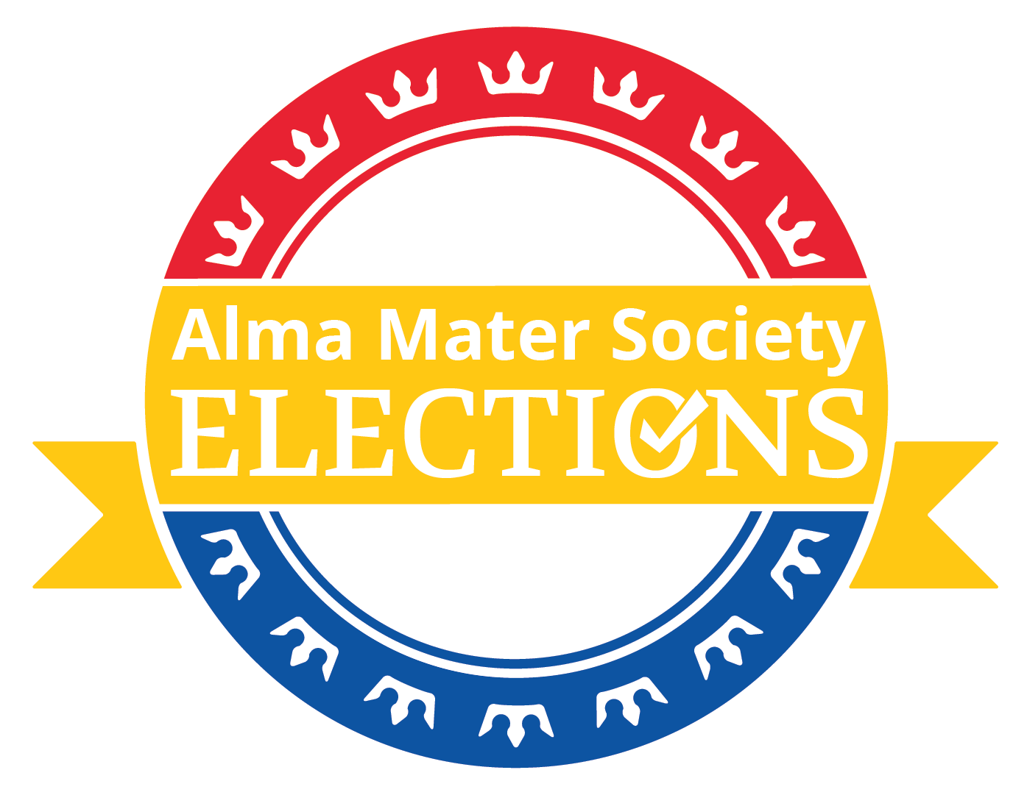

2023 Trustee Nomination Package

Thank you for your interest in the Undergraduate Trustee position. This package contains all the information and forms that you will need to participate in the election process. Please read this document in its entirety and fully understand its contents, paying particular attention to the Dates section, as you will be held completely responsible for all of the material contained herein. Please view this document in desktop mode! Please note that all times for information sessions, debates and deadlines are in Kingston time (EST). This document is integral to understanding the commitment that the AMS executive requires and is therefore a required piece of reading.

If you have any questions or run into any problems, the Elections Team will be more than happy to help you out. We can be reached by using the contact information below. We strongly encourage you to ask for clarification of any of the rules or regulations regarding soliciting nominations or campaigning and encourage you to discuss your campaign strategy with us to ensure that you are within campaign rules and regulations. There are no stupid questions, and it is better to be safe than sorry! Also, we look to you for comments or suggestions to help make elections and referenda run more smoothly. Thank you for being patient through the process of this election! We strongly encourage you to look at every aspect of this document. It lists platform requirements, policy and procedure, and cheat sheets!

Please fill out the Nomination Form to submit your intention to run.

Good luck!

AMS Elections Team Contact Information:

Nate Feldman, Chief Electoral Officer (ceo@ams.queensu.ca)

Amir Ali Golrokhian-Sani, Secretary of Internal Affairs (secretary@ams.queensu.ca)

Calder Bryson, Logistics and Finance Deputy (logistics_deputy@ams.queensu.ca)

Caroline Abouchar, Disputes Deputy (disputes_deputy@ams.queensu.ca)

Sylvia Kathirkamanathan, Marketing Deputy (marketing_deputy@ams.queensu.ca)

Important Dates

January 12th | Nomination Period Opens  You are now permitted to gather signatures using the instructions found in this document.
January 18th | Nominations Close  Nomination packages are due on this day before 12pm EST. Please ensure you have 210 or more signatures (1% of AMS members).
January 26th | Validation Day  The Elections Team will verify all of the collected nomination signatures. All candidates will go before AMS Assembly to be ratified thus allowing campaigning to begin. Please submit any graphics, campaign materials, and websites you would like approved at this time to guarantee they are ready for the start of campaigning.
January 29th | Campaigning Begins  Please refer to AMS Elections Policy Manual for regulation on campaigning.
February 2nd | All Candidates Debate  Mandatory to attend for teams. Platforms must be released 24 hours ahead of time.
February 5th | Campaigning Ends  This is just the last day before voting commences. Campaigning can still take place during the election days.
February 6th & 7th | VOTING DAYS  Voting closes at 8pm on the second day. Referenda groups will be informed of their results a day after voting, at the latest.
February 8th | Referendum Expenses Receipts Due  Please turn in all campaign receipts to logistics_deputy@ams.queensu.ca BEFORE 5:00 pm on the 8th. The campaign-spending limit is $400. If you do not submit expenses by this date, you will not be reimbursed, and you will be fined and/or disqualified. This only applies to teams who are choosing to spend during their campaign.

How Should I Get Signatures?
This year, we require you to submit the list of signatures (name, student number and email) in a table format, either attached to this document or submitted separately. Usually, this happens in person, but this year it will be all online.

Important Information:
- Anyone can nominate you, as long as they are a fee-paying AMS Member;
- 210 or more signatures are required;
- A reminder that campaigning during this time will result in consequences. While you can share the information of “My name is X, and I am running for Y”, you cannot disclose any of your platform;
- Please try to uphold anonymity for signatories. It is discouraged to share a document where everyone can fill in their information. Rather, it is encouraged to have them fill out a form, or give you the information directly;
- Ensure that students fill out the email section of the form so that we can verify their identity;
- Once you have completed the required signatures please delete the form, to protect the privacy of signatories.

Example of a way to solicit nominations:
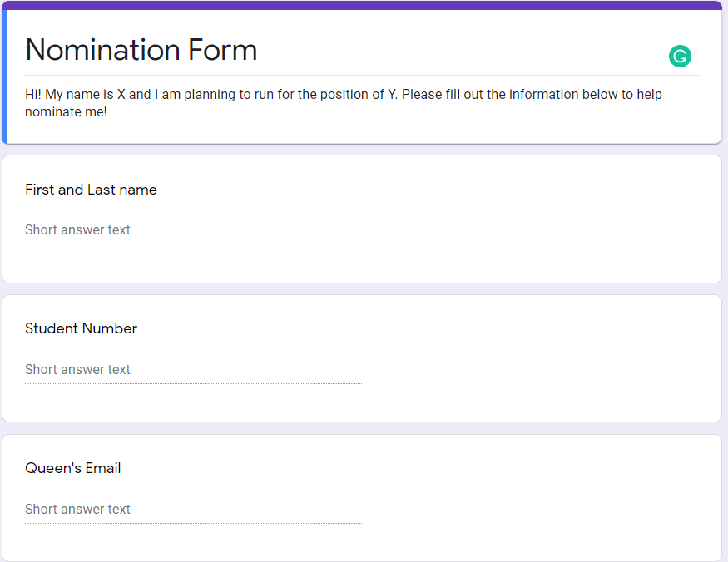
Example of Required Format for Signatures:

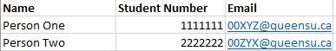

CLARIFICATIONS

- You need to collect 210 (1%) signatures from members of the AMS students When obtaining nominations, please ensure that all names and student numbers are clearly legible. Please ensure that nominators write their student number, not their phone number.
- Non-compliance with nomination rules may result in disqualification of your candidacy, as there are no other forms of control available until after validation. Appeals may be directed to the Chief Electoral Officer (ceo@ams.queensu.ca).
- The campaign-spending limit has been set at $200.00. Please keep ALL receipts and note what you spent on the Expense Summary Form. Hand in both receipts and the Expense Summary Form no later than Midnight on February 8th.
- All campaign materials (including any advertisements you may want to place in campus publications, etc. and any new social media presence [Facebook pages, events, groups and profiles, as well as Twitter accounts]) must be approved by the CEO.
- There is to be no campaigning during the nomination periods. You can only ask people to sign your nomination form, and, if they ask, explain what you are doing (i.e. running for an elected position).
- You are responsible for the activities of all individuals associated with your campaign. Please ensure that they fully understand the rules and regulations regarding the soliciting of nominations and campaigning.
- You are responsible for keeping a list of all members associated with your campaign and providing such list to the CEO within 8 hours of request.
- This is NOT a complete list of rules and policy, so it is IMPERATIVE that you read and understand all parts of the Constitution, AMS Elections Policy and other information contained within this package. All relevant AMS Policy can be found under the governance section of myams.org.
- Complaint forms for candidates and members at large can be found at myams.org/elections to submit infractions of elections policy or the Queen’s Student Code of Conduct.

Campaigning “Cheat Sheet”

EXPENSE INFORMATION

Trustee candidates: $200 campaign-spending limit

- Keep track of ALL expenses and corresponding receipts related to the campaign, both paper and electronic. Make sure to stay below your spending limit! Collect receipts for all donations as they count against the spending limit.

- Notify the Elections Team before use of any materials that do not incur a cost. These must be approved by the CEO prior to use. The CEO can sanction you if you do not notify them of these materials.

- Submit your completed Expense Summary Form and campaign expense receipts in a single email to logistics_deputy@ams.queensu.ca no later than 11:59PM on February 8th. No reimbursements will be issued to any expenses submitted past this date or without a receipt. Paper forms or receipts may be scanned and attached in PDF or JPEG format.

- After review, approved eligible expenses will be reimbursed and deposits will be returned on February 24th.
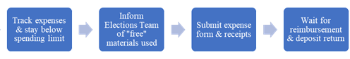

Contact Information
Calder Bryson, Logistics Deputy: logistics_deputy@ams.queensu.ca
The finance and logisticss deputy helps to manage deposits and campaign funds throughout the elections process. Feel free to reach out with any questions on policies or procedures pertaining elections spending.

AMS Secretariat
ALMA MATER SOCIETY OF QUEEN’S UNIVERSITY

2023 Expense Summary Form

Please attach and itemize all receipts. Submit form and receipts in a single email to logistics_deputy@queensu.ca . You may photocopy this sheet or write on the back. You are permitted to provide this information in a spreadsheet form.

Contact Information
Name: _______________________________ Phone Number: ____________________
E-mail: _______________________________ Campaign: ________________________
Item Description | Receipt✓ | Per Unit Cost | Number | Total Item Cost
E.g. Facebook ads, website hosting, etc… | ✓ | $5/day | 7 days | $35

Total Expenses: _________________

More Resources

AMS Executive How to Run Guide

Elections Policy

